**Autonomous Reconfiguration of Heterogenous Robots**

Insertion Sort

Split in 2

Melt

Grouping

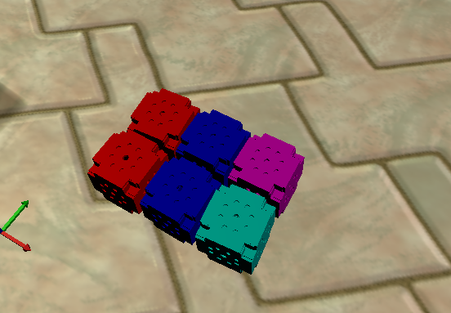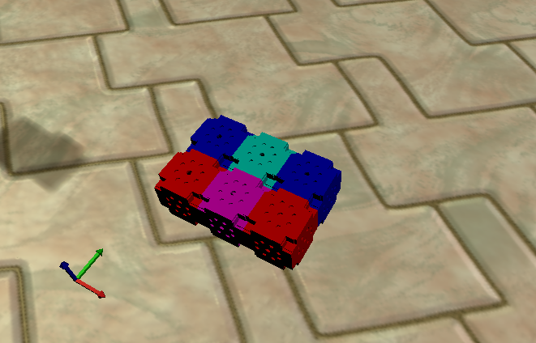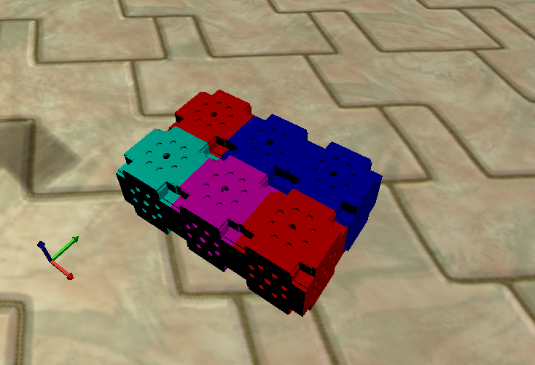

**0**

**1**

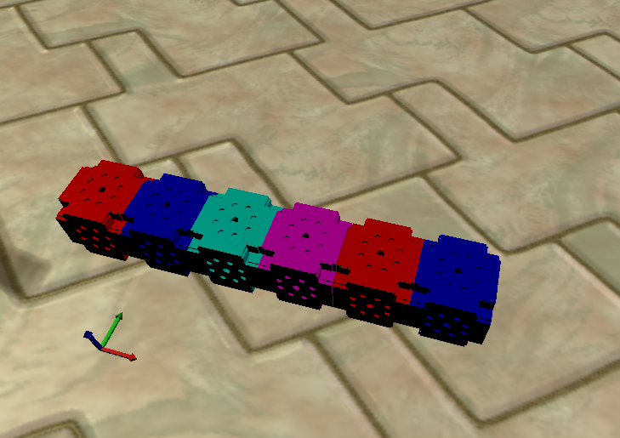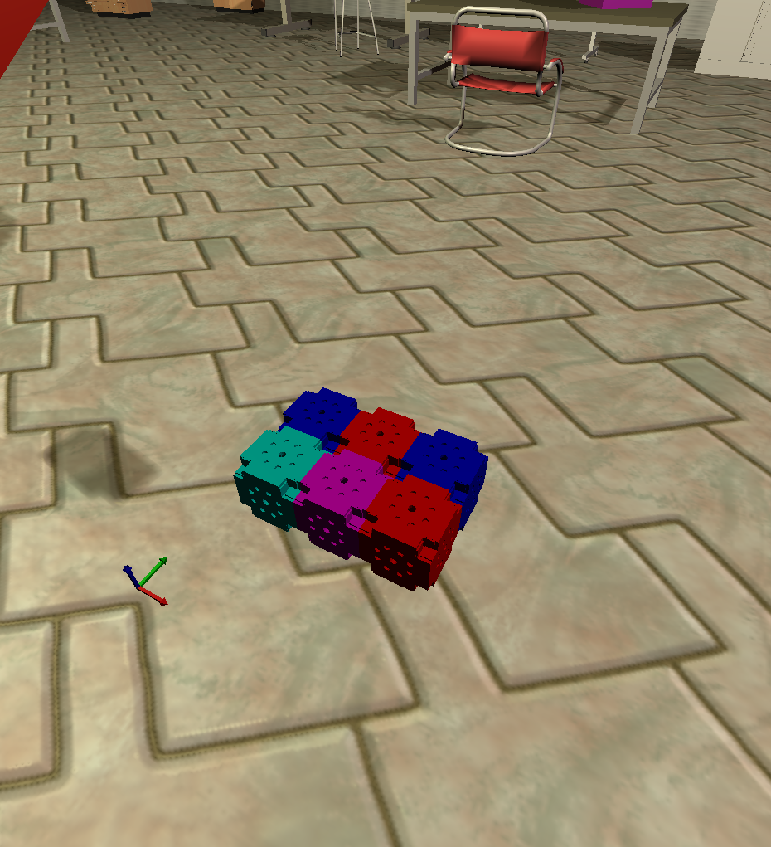

**0**

**1**

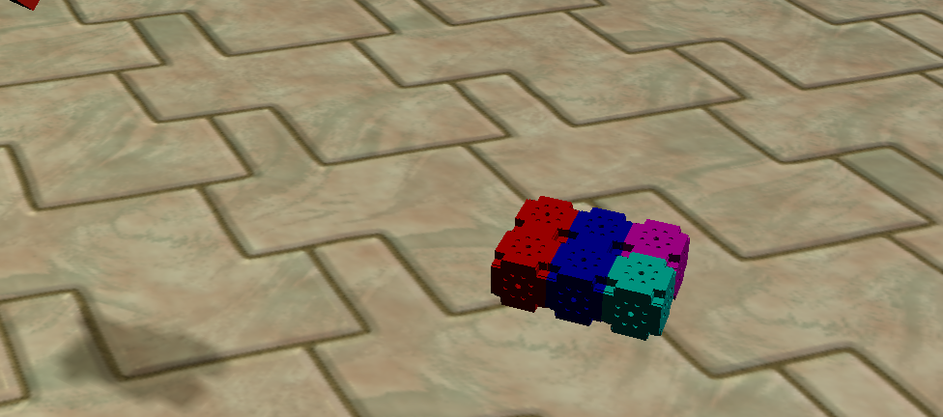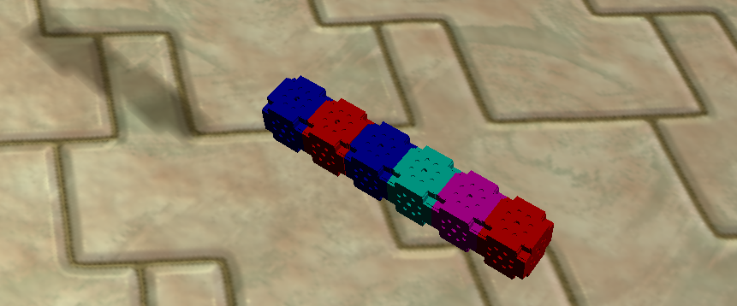

**Root module**

**Root module**

Split in 2

Bubble Sort

Modules treated as nodes in graph

A root module is chosen

BFS is used to find **isolated** **modules** in the structure and the path to them from root

Path is converted into a series of coordinates outside the structure

Chain is sorted by splitting in 2, bubble sorting each row, then insertion sorting the rows back together

Grow the takes sorted chain into goal structure, performing the inverse of melt

Preserves module orientation

Could be adapted to work with different sized modules

Grow